**CRICKET MANAGEMENT** **SYSTEM**

**MINI PROJECT REPORT**

**Submitted by**

**JAYASRI.S (111713104045)**

**LAKSHMIPRIYA.J (111713104054)**

**MEENA.K (111713104061)**

**OF**

**COMPUTER SCIENCE AND ENGINEERING**

**RMK ENGINEERING COLLEGE**

KAVARIPETTAI.

Ta**ble of Contents**

1. ABSTRACT……………………………………………………………………5
2. SOFTWARE REQUIREMENT SPECIFICATION…………………………..7
   1. INTRODUCTION…………………………………………….7
   2. PURPOSE……………………………………………………..7
   3. SCOPE………………………………………………………...7
   4. FEASIBILITY STUDY………………………………………7
   5. OVERALL DESCRIPTION………………………………….8
      1. Product features…………………………………….8
      2. User Characteristics…………………………………8
      3. Operating Environment……………………………..8
      4. Design constraints…………………………………..8
      5. Assumption and Dependencies……………………..9
   6. SPECIFIC REQUIREMENTS………………………………..10
      1. External Interface Requirements…............................10
         1. User Interface ……………………....10
         2. Hardware Interface…………………10
         3. Software Interface…………………..10
      2. Functional requirements……………………………..10
         1. Administration module……………...10
         2. Sport module………………………...10
   7. DESIGN CONSTRAINTS…………………………………….11
3. UML DIAGRAMS……………………………………………………………...13
4. SOURCE CODE………………………………………………………………...22
5. SCREEN SHOTS………………………………………………………………..28
6. CONCLUTION………………………………………………………………….30

**ABSTRACT**

**ABSTRACT**

The game of Cricket is one which is followed and loved by a large proportion of the population across the world. The liking goes to such an extent that people even end up having games of cricket on their computers. In this paper we discuss about the development of a cricket game, Cricket Strategy Game. This is a special game, different from others, as it is one focusing on the strategizing, managing, and captaining aspects of cricket. There are many games that simulate a real game of cricket, but a game that simulates the role of a captain, manager or director in the sport of cricket are rarely found. Hence we present the Cricket Strategy Game in this paper, file handling, and few concepts of cricket are mixed proportionately to develop this game and make it interesting for its users and players. The random numbers generated are cleverly assigned values to vary according to the inputs of the user, thus making the game a very dynamic and filled with astonishment. Through this game we successfully simulate the real life role of a cricket team captain or manager or director. The players will feel the exact feeling that the captain feels in a match scenario. The game has been designed in such a way, and the technology and concepts are used so effectively, to develop this Cricket Strategy Game in a way that the users will find it really simulating and real-life like.

**SOFTWARE**

**REQUIREMENT**

**SPECIFICATION**

**( SRS)**

**Software Requirement Specification for Sport Management System:**

**1. Introduction**

The SRS is produced at the culmination of the analysis task. The function and performance allocated to software as part of the system engineering and refined by establishing a complete information description, a detailed functional description, a representation of system behavior, indication of performance requirements and design constrains, appropriate validation criteria and the other information related to requirements.

**1.1.** **Purpose:-**

This is the software requirement specification for Sport Event Management System. This will only contain higher level requirement specification for Sport Event Management System. Sport Event Management System provides a framework for many other components which dwell on top of it. Version of this document is 1.0 and any changes to requirements or detailed software requirements will be published in a revised version.

**1.2. Scope:-**

The project vision is to provide software that will improve the efficiency, reduce cost and time associated with planning and management of a Sport Event. Initially we will only focus on achieving core functionality in the system and developing more modules that will help to manage a core of a sport event. Future plans for other extensions will be decided on completion of core functionalities.

Even though this project focuses on the fairly large events, small events should also be able use system to good effects. By use of this system, people who are directly benefited include decision makers, organizers, managers, players, officials, officers, media and fans. There can be many other indirect benefactors.

**1.3. Feasibility Study:-**

The overall scope of the feasibility study was to provide sufficient information of Management of an intramural sport program on a college or university campus can be a daunting task irrespective of whether the institution accommodates a small student body or a large population. Administrators of such a program need to manage not just the sports activities, but also the teams and athletes that participate in the various sports as well as maintain statistics that are related to the program. In addition, coordinating the scheduling of contests, facilities, and officials as well as manipulating the large amount of data in various logical formats becomes an overwhelming task.

**2. OVERALL DESCRIPTION**

## Product Features

Main features of the product can be listed as below.

1. Control access to resources information –

System will control the access to resource information and it will ensure the system security by giving different access levels to different user groups.

1. Accommodation and transport allocation –

System will handle accommodation and transportation facilities to the players and visitors.

1. Event scheduling –

System will generate the schedule automatically.

1. Score live update –

System will publish live scores though World Wide Web and give interfaces to access data to registered media

1. Customizability
2. Extensibility

## 

## 2.1 User Classes and Characteristics

There are three types of users who are involved with this Framework. They are

1. Administrators

Root administrators

Local administrators

IT administrators

2. Scorers

3. Spectators

All the above specified users should know some amount of English and the basics of operating a computer and should be familiar with internet and any web browser like MS Internet Explorer, Mozilla FireFox etc.

Other than above user characteristics root administrators should have specific knowledge to install software.

## 2.2 Operating Environment

Windows 9x, windows ME, windows 2000, windows 2003, windows XP or Linux can be used as the operating system.

## 2.3 Design and Implementation Constraints

* Should have a server with open source software and enough performance to handle the expected traffic.
* Should have an internet connection
* Other computers provided should have the following installed

MS Internet Explorer 5.0 or higher or Mozilla Firefox 1.0 or higher

* Should have a well designed and maintained database.

## 

## 2.4 Assumptions, Dependencies and Guidelines

### Assumptions

* System users have their own server
* All the computers used are networked

### Dependencies

Open source software

**3. SPECIFIC REQUIREMENTS**

It describes all the details that the software developer need to know for designing and developing the system. This is typically the largest and most important part of the document.

**3.1. External Interface Requirements:-**

**3.1.1. User Interface:-**

User interface is designed in a user friendly manner and the user, in another end he has to give the order, for that he will interface with keyboard and mouse.

**3.1.2. Hardware Interface:-**

1) OS – windows XP

2) Hard disk – 80 GB

3) RAM – 1 GB

4) Keyboard – Standard QWERTY keyboard for interface

5) Mouse – Standard mouse with 2 buttons

**3.1.3. Software Interface:-**

1) Front end – Java language

2) OS – Net Beans IDE 6.9.1

3) Back end – SQL Server 2005

**3.2. Functional Requirements:-**

**3.2.1. Administration module:-**

This module enables the user to insert, update, view and delete the sports information.

**3.2.2. Sport module:-**

* Palyer,Name,game,Age,Sex,Address,Phone Number,Weight
* Idno, Game, Player, Coach, Date of match, EnterenceFee, Date of result.
* Updation like deletion and modification is done.

**3.4. Design Constraints:-**

This will help the umpire or users to view the records of the Sports immediately whenever necessary. They can also fix the Match of the particular Sports person. This software also has the ability to add, update and delete the record whenever needed. This project will help to smoother the process of the sports club activites.

**UMLDIAGRAMS**

**UML Diagrams:**

**1)Use-Case Diagram:**



**2)Class Diagram:**

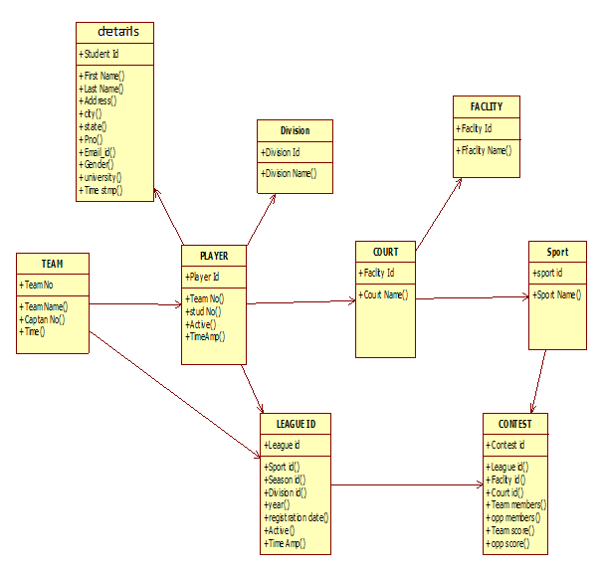

**3)Sequence Diagram**



**4)Collaboration diagram:**



**5)Activity diagram:**



**6)State chart diagram:**



**7)Component diagram:**



**8)Deployment diagram:**



**SOURCE CODE**

**Source code:**

1. **Login.java**

import javax.servlet.*;

import java.io.*;

import javax.servlet.http.*;

public class signup1 extends HttpServlet

{

public void service(HttpServletRequest req,HttpServletResponse res)

{

try

{

PrintWriter out = res.getWriter();

res.setContentType("text/html");

out.println("<HTML>");

out.println("<HEAD>");

out.println("<TITLE> SignUP </TITLE>");

out.println("</HEAD>");

out.println("<body background= Screenshot_2015-09-17-13-08-49.png><center>");

out.println("<form method=post action=\"http://localhost:8080/servlet/userper\" > ");

out.println("<font size=7 face=\"arial black\" color=red><U>plese login</U></b></font>");

out.println("<TABLE border=0 >");

out.println("<TR><td align=\"center\">UserName :

<input type=text\" NAME=\"username\">(Minimum 4 characters)</td></TR>");

out.println("<TR><td><CENTER> PassWord

<INPUT TYPE=\"password\" NAME=\"pwd\"> &nbsp;&nbsp;&nbsp;(Minimum 4 characters)</CENTER></td></TR>");

out.println("<TR><td> <CENTER>RetypePassWord :&nbsp;<INPUT TYPE=\"password\" NAME=\"retypepassword\"> (Minimum 4 characters)</CENTER></td></TR><BR>");

out.println("<TR><TD><CENTER><U><FONT SIZE=\"6\" COLOR=\"green\">Profile Information:</FONT></U></CENTER></TD></TR>");

out.println("<TR><td><CENTER> FirstName :

<INPUT TYPE=\"text\" NAME=\"firstname\"></CENTER> </td></TR>");

out.println("<TR><td> <CENTER>MiddleName :

<INPUT TYPE=\"text\" NAME=\"middlename\"> </CENTER></td></TR>");

out.println("<TR><td><CENTER> LastName :

<INPUT TYPE=\"text\" NAME=\"lastname\"></CENTER> </td></TR>");

out.println("<TR><TD><CENTER>Address

out.println("<TEXTAREA NAME=\"add\" ROWS=\"5\" COLS=\"17\"></TEXTAREA></TD></TR>");

out.println("<TR><td><center>City”);

out.println("<INPUT TYPE=\"text\" NAME=\"city\"> </td></center></TR>");

out.println("<TR><td><CENTER>State:”);

out.println("<INPUT TYPE=\"text\" NAME=\"state\"> </td></CENTER></TR>");

out.println("<TR><td>”);

out.println("<INPUT TYPE=\"text\" NAME=\"pcode\"> </td></TR>");

out.println("<TR><td><CENTER>Phone No “);

out.println("<INPUT TYPE=\"text\" NAME=\"pn\"></CENTER> </td></TR>");

out.println("<TR><td><CENTER>E mailed:”);

out.println("<INPUT TYPE=\"text\" NAME=\"ed\"></CENTER> </td></TR>");

out.println("<TR><td>Gender");

out.println("<select NAME=\"gender\">");

out.println(" <option value=\"Male\">Male");

out.println(" <option value=\"Female\">Female");

out.println("</select></td></TR>");

out.println("<TR><TD>Occupation “);

out.println("<SELECT NAME=\"occ\">");

out.println(" <option>Business");

out.println(" <option>Student");

out.println("<option>employee");

out.println("</SELECT></TD></TR>");

out.println("<TR><TD>How did you Know About Us? :");

out.println("<SELECT NAME=\"know\">");

out.println(" <option>NewsPaper");

out.println(" <option>Friends");

out.println(" <option>Wallpaper");

out.println("<TD><CENTER><INPUT TYPE=submit value=\"Submit\">”);

out.println("</form> ");

out.println("<INPUT TYPE=button value=Cancel>&nbsp;&nbsp;&nbsp;&nbsp;&nbsp;");

out.println("<INPUT TYPE=button value=Back>&nbsp;&nbsp;&nbsp;&nbsp;&nbsp;");

out.println("</CENTER>");

out.println("</TD> </tr> ");

out.println("</TABLE></CENTER>");

//out.println("</form> ");

out.println("</body>");

out.println("</html>");

}

catch(Exception e)

{

e.printStackTrace();

}}}

**ii)Register.java**

import javax.servlet.*;

import javax.servlet.http.*;

import java.io.*;

import java.sql.*;

import java.util.*;

public class admpadel extends HttpServlet

{

Statement st;

Connection con;

String s1,s2,s3,s4,s5,s6,s7,s8,s9,s10,s11,s12,s13,s14,s15,s16,s17,s18,s19,s20,s;

public void doGet(HttpServletRequest req,HttpServletResponse res)

{

try

{

PrintWriter out = res.getWriter();

Class.forName("sun.jdbc.odbc.JdbcOdbcDriver");

con = DriverManager.getConnection("jdbc:odbc:reddy","chinnu","nisha");

st=con.createStatement();

ResultSet rs,rs1;

s=req.getParameter("pcode");

System.out.println(s+"patmod");

rs=st.executeQuery("select * from sport where sportid='"+s+"'");

System.out.println(s+"Dhoni");

if(rs.next())

{

s1=rs.getString(3);

s2=rs.getString(4);

s3=rs.getString(5);

s4=rs.getString(6);

s5=rs.getString(7);

s6=rs.getString(8);

s7=rs.getString(9);

s8=rs.getString(10);

s9=rs.getString(11);

s10=rs.getString(12);

s11=rs.getString(13);

s12=rs.getString(14);

}

System.out.println(s+"patmodxxxyyy");

System.out.println(s3);

System.out.println(s4);

StringTokenizer st = new StringTokenizer(s3,"/");

s15=st.nextToken();

s16=st.nextToken();

s17=st.nextToken();

System.out.println(s15);

System.out.println(s16);

System.out.println(s17);

StringTokenizer st1 = new StringTokenizer(s4,"/");

s18=st1.nextToken();

s19=st1.nextToken();

s20=st1.nextToken();

System.out.println(s18);

System.out.println(s19);

System.out.println(s20);

res.setContentType("text/html");

out.println("<html>");

out.println("<body background='c:/javawebserver2.0/servlets/wedflo_15.gif'>");

out.println("<center>");

out.println("<form name=pat action='admpdel'> ");

out.println(" <td><input type=\"hidden\" name=\"pcode\" value="+s+" ></td>");

out.println("<font size=7 color=\"red\" face=arial black><b>+</b></font><font size=6 color=\"green\"><u><b>sport Form</b></u></font><font size=7 color=\"red\" face=arial black><b>+</b></font>");

out.println("<br><br>");

out.println("<table>");

out.println("<tr>");

out.println(" <td><b>sports Name:</b></td>");

out.println(" <td><input type=\"text\" name=\"Sname\" value="+s1+" size=20></td>");

out.println("</tr>");

out.println("<tr>");

out.println(" <td><b>Age:</b></td>");

out.println(" <td><input type=\"text\" name=\"age\" value="+s2+" size=20></td>");

out.println("</tr>");

out.println("<tr>");

out.println(" <td><b>Date Of Birth:</b>Format-(DD/MM/YYYY)</td>");

out.println(" <td><input type=\"text\" name=\"dob\" value="+s3+" size=20></td>");

out.println("</tr>");

out.println("<tr>");

out.println(" <td><b>Registration Date:</b> Format-(DD/MM/YYYY )</td>");

out.println(" <td><input type=\"text\" name=\"regdate\" value="+s4+" size=20></td>");

out.println("</tr>");

out.println("<tr>");

out.println(" <TD><B>House No:</B></TD>");

out.println(" <td><input type=\"TEXT\" NAME=\"hno\" value="+s5+" size=20></td>");

out.println("</tr>");

out.println("<tr>");

out.println(" <TD><B>Street:</B></TD>");

out.println(" <td><input type=\"TEXT\" NAME=\"street\" value="+s6+" size=20></td>");

out.println("</tr>");

out.println("<tr>");

out.println(" <TD><B>City:</B></TD>");

out.println(" <td><input type=\"TEXT\" NAME=\"city\" value="+s7+" size=20></td>");

out.println("</tr>");

out.println("<tr>");

out.println(" <td><B>Phone:</td>");

out.println(" <td><INPUT TYPE=\"text\" NAME=\"phone\" value="+s8+" size=20></td>");

out.println("</tr>");

out.println("<tr> ");

out.println(" <td><B>Fax :</td>");

out.println(" <td><INPUT TYPE=\"text\" NAME=\"fax\" value="+s9+" size=20></td>");

out.println(" <td><B>E-mail(if any):</td>");

out.println(" <td><INPUT TYPE=\"text\" NAME=\"eid\" value="+s10+" size=20></TD>");

out.println("</TR>");

out.println("<tr>");

out.println(" <td><b>State:</b></td>");

out.println(" <td><input type=\"text\" name=\"st1\" value="+s11+" size=20></td>");

out.println(" <td><b>Country:</b></td>");

out.println(" <td><input type=\"text\" name=\"cou1\" value="+s12+" size=20></td>");

out.println("</tr>");

out.println("</table>");

out.println("<br><br><br>");

out.println(" <td><input type=\"submit\" value=\"Delete\" onClick=\" return patcheck()\"></td>");

out.println(" <td><input type=\"button\" value=\"Back\" onClick=window.history.go(-1)></td>");

out.println("</center>");

out.println("</form>");

out.println("</body>");

out.println("</html>");

}

catch(Exception e)

{

e.printStackTrace();

}}}

**SCREEN SHOTS**

**Main from:**

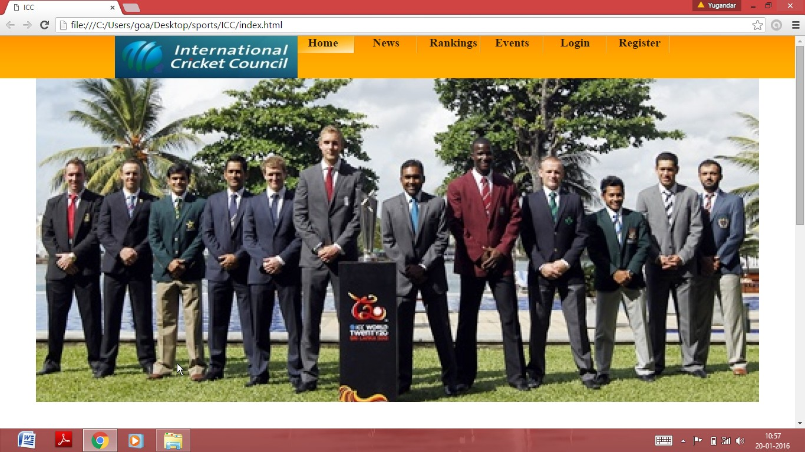

**Content from:**

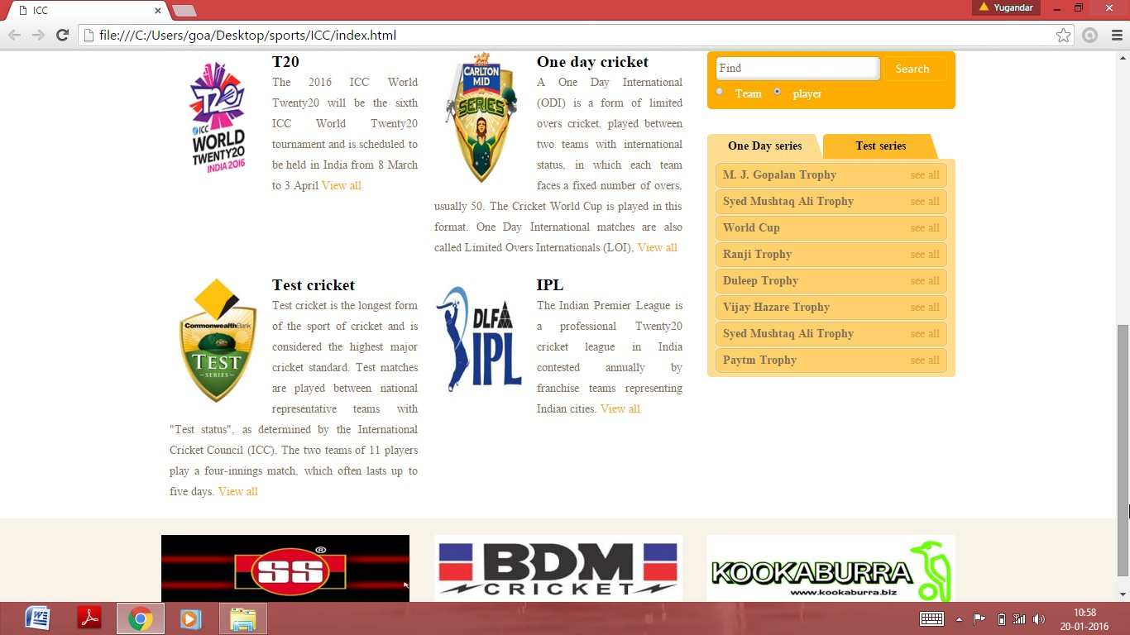

**Login from:**

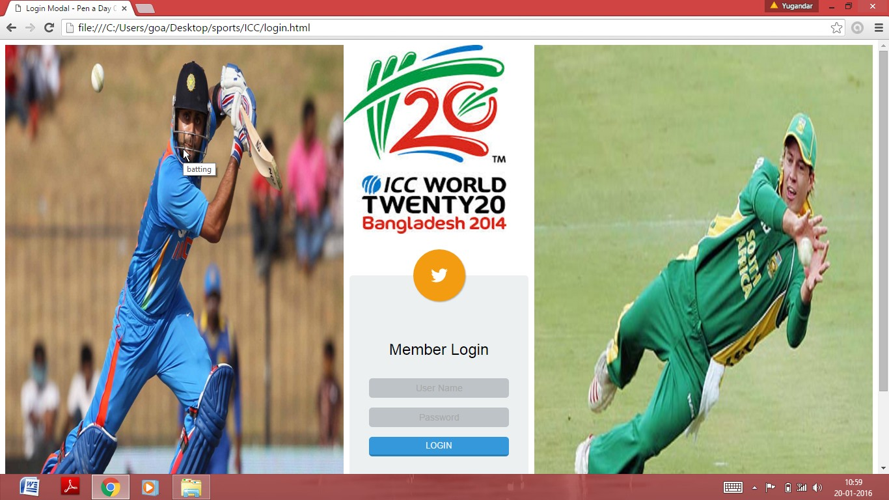

**Ranking from:**

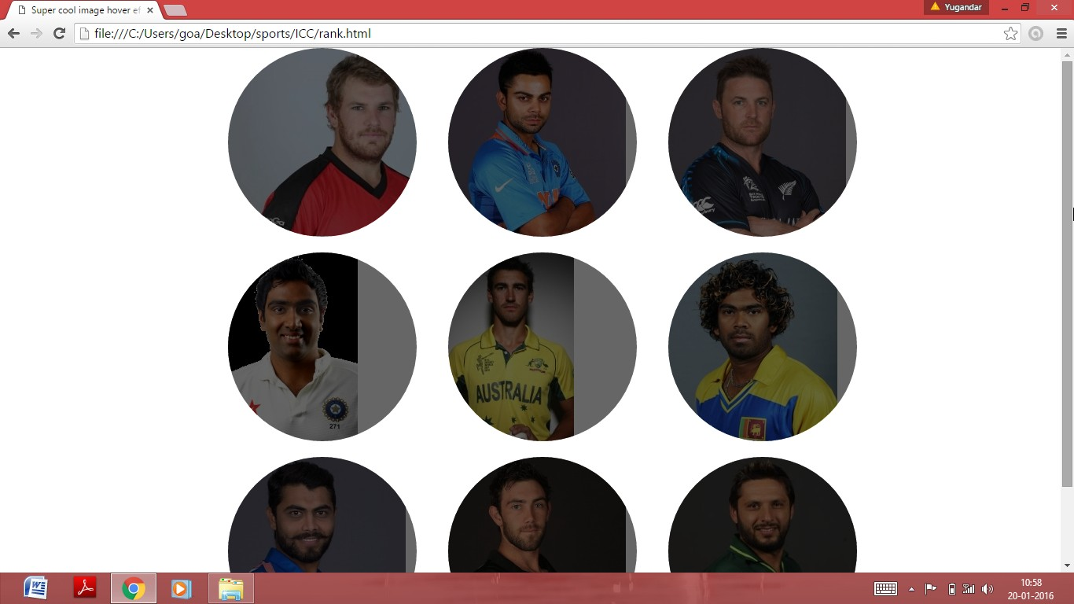

**Registerfrom:**

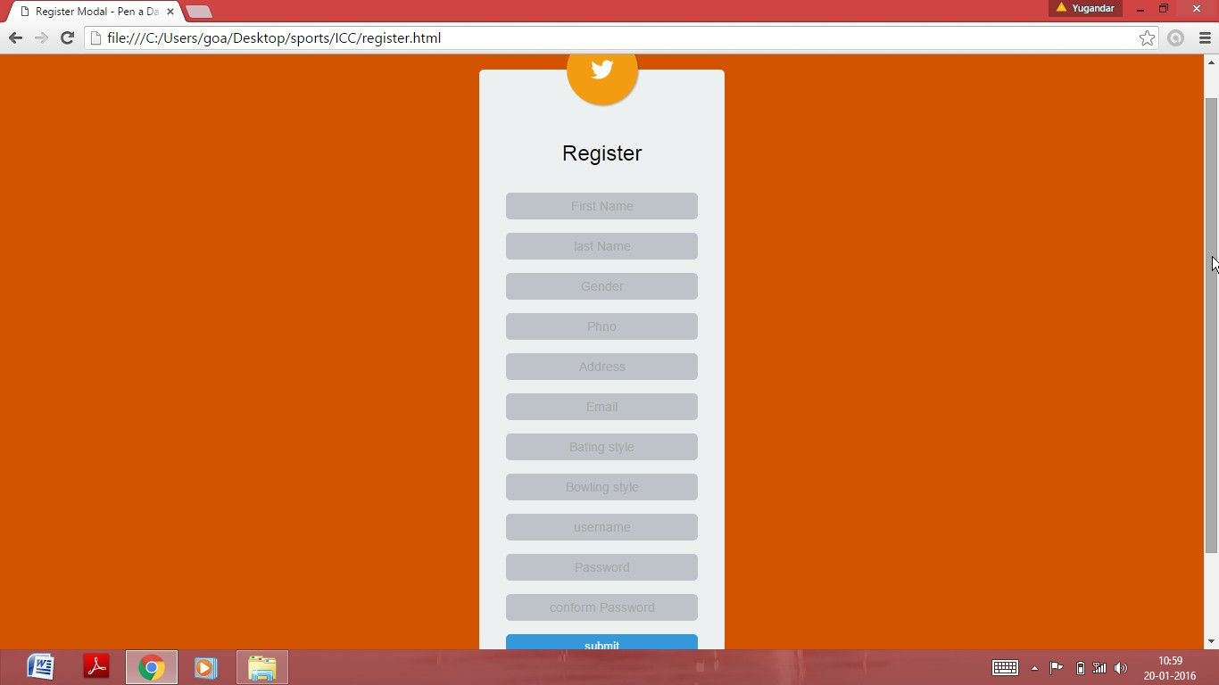

**Conclusion:**

Thus, this system is made for cricket management to perform their task easily and this software replaces the manual cricket system into automated cricket management system.